Работал под ЦЫГАНОВЫМ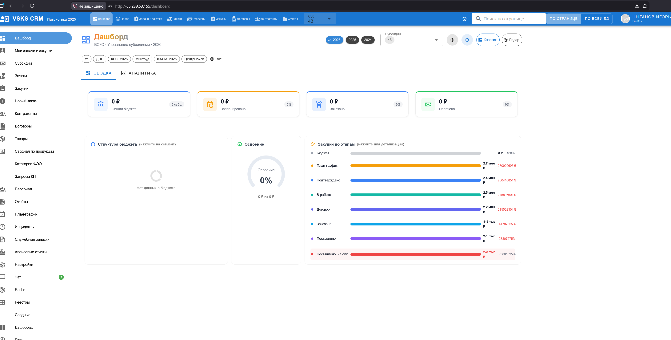Почему у Цыганова так странно отображается поле «закупки по этапам» когда не выбрана никакая субсидия.
Почему цыганов прописан как ведущий специалист, где это прописано и почему нельзя ему изменить должность . Сейчас у него должност нет , он почему то прописан в отделе МТО, хоят его плашка в БУХГАЛТЕРИИ сейчас , должность не прописана,новая должность не прописывается и не сохраняется.

Пытался поменять разрешения Цыганову , от СУПЕПЕР АДМИНА. Вот такая ошибка. Код: INTERNAL_ERROR
Сообщение: Внутренняя ошибка сервера
Correlation ID: e63b04ed-c837-48bd-91ed-f5d7131a403c

Детали:
Traceback (most recent call last):
File "/usr/local/lib/python3.11/site-packages/anyio/streams/memory.py", line 98, in receive
return self.receive_nowait()
^^^^^^^^^^^^^^^^^^^^^
File "/usr/local/lib/python3.11/site-packages/anyio/streams/memory.py", line 93, in receive_nowait
raise WouldBlock
anyio.WouldBlock

During handling of the above exception, another exception occurred:

Traceback (most recent call last):
File "/usr/local/lib/python3.11/site-packages/starlette/middleware/base.py", line 78, in call_next
message = await recv_stream.receive()
^^^^^^^^^^^^^^^^^^^^^^^^^^^
File "/usr/local/lib/python3.11/site-packages/anyio/streams/memory.py", line 118, in receive
raise EndOfStream
anyio.EndOfStream

During handling of the above exception, another exception occurred:

Traceback (most recent call last):
File "/usr/local/lib/python3.11/site-packages/starlette/middleware/errors.py", line 162, in __call__
await self.app(scope, receive, _send)
File "/usr/local/lib/python3.11/site-packages/starlette/middleware/base.py", line 108, in __call__
response = await self.dispatch_func(request, call_next)
^^^^^^^^^^^^^^^^^^^^^^^^^^^^^^^^^^^^^^^^^^^^
File "/app/app/__init__.py", line 374, in add_correlation_id
response = await call_next(request)
^^^^^^^^^^^^^^^^^^^^^^^^
File "/usr/local/lib/python3.11/site-packages/starlette/middleware/base.py", line 84, in call_next
raise app_exc
File "/usr/local/lib/python3.11/site-packages/starlette/middleware/base.py", line 70, in coro
await self.app(scope, receive_or_disconnect, send_no_error)
File "/usr/local/lib/python3.11/site-packages/starlette/middleware/exceptions.py", line 79, in __call__
raise exc
File "/usr/local/lib/python3.11/site-packages/starlette/middleware/exceptions.py", line 68, in __call__
await self.app(scope, receive, sender)
File "/usr/local/lib/python3.11/site-packages/fastapi/middleware/asyncexitstack.py", line 20, in __call__
raise e
File "/usr/local/lib/python3.11/site-packages/fastapi/middleware/asyncexitstack.py", line 17, in __call__
await self.app(scope, receive, send)
File "/usr/local/lib/python3.11/site-packages/starlette/routing.py", line 718, in __call__
await route.handle(scope, receive, send)
File "/usr/local/lib/python3.11/site-packages/starlette/routing.py", line 276, in handle
await self.app(scope, receive, send)
File "/usr/local/lib/python3.11/site-packages/starlette/routing.py", line 66, in app
response = await func(request)
^^^^^^^^^^^^^^^^^^^
File "/usr/local/lib/python3.11/site-packages/fastapi/routing.py", line 274, in app
raw_response = await run_endpoint_function(
^^^^^^^^^^^^^^^^^^^^^^^^^^^^
File "/usr/local/lib/python3.11/site-packages/fastapi/routing.py", line 191, in run_endpoint_function
return await dependant.call(**values)
^^^^^^^^^^^^^^^^^^^^^^^^^^^^^^
File "/app/app/routers/hierarchy.py", line 490, in update_user_org_position
)).scalar_one_or_none()
^^^^^^^^^^^^^^^^^^^^
File "/usr/local/lib/python3.11/site-packages/sqlalchemy/engine/result.py", line 1502, in scalar_one_or_none
return self._only_one_row(
^^^^^^^^^^^^^^^^^^^
File "/usr/local/lib/python3.11/site-packages/sqlalchemy/engine/result.py", line 813, in _only_one_row
raise exc.MultipleResultsFound(
sqlalchemy.exc.MultipleResultsFound: Multiple rows were found when one or none was required.

И напомни мне почему у меня Цыганов не видит другие закупки , хотя он хозяин акаунта.В ролях должно быть указана возможность видимости закупок других людей и договора. Сразу включи что начальники отдела и люди к которым идут связи и которые могут давать задачи по иерерахии видят звсе закупки и задачи сотрудника.

Мне кажется эта логика должна уже реализовывться , но я сейчас назначил, Цыганова, что он может ставить задачи всей ВСКС, но список закупко не появился. к
«Код: INTERNAL_ERROR
Сообщение: Внутренняя ошибка сервера
Correlation ID: c9d5fd4e-3775-4310-80de-8a249ae2f103

Детали:
Traceback (most recent call last):
File "/usr/local/lib/python3.11/site-packages/sqlalchemy/dialects/postgresql/asyncpg.py", line 557, in _prepare_and_execute
self._rows = await prepared_stmt.fetch(*parameters)
^^^^^^^^^^^^^^^^^^^^^^^^^^^^^^^^^^^^^^
File "/usr/local/lib/python3.11/site-packages/asyncpg/prepared_stmt.py", line 176, in fetch
data = await self.__bind_execute(args, 0, timeout)
^^^^^^^^^^^^^^^^^^^^^^^^^^^^^^^^^^^^^^^^^^^
File "/usr/local/lib/python3.11/site-packages/asyncpg/prepared_stmt.py", line 241, in __bind_execute
data, status, _ = await self.__do_execute(
^^^^^^^^^^^^^^^^^^^^^^^^
File "/usr/local/lib/python3.11/site-packages/asyncpg/prepared_stmt.py", line 230, in __do_execute
return await executor(protocol)
^^^^^^^^^^^^^^^^^^^^^^^^
File "asyncpg/protocol/protocol.pyx", line 207, in bind_execute
asyncpg.exceptions.UniqueViolationError: duplicate key value violates unique constraint "ux_user_org_dept"
DETAIL: Key (user_id, org_id, COALESCE(dept_id, 0))=(5, 1, 0) already exists.

The above exception was the direct cause of the following exception:

Traceback (most recent call last):
File "/usr/local/lib/python3.11/site-packages/sqlalchemy/engine/base.py", line 1969, in _exec_single_context
self.dialect.do_execute(
File "/usr/local/lib/python3.11/site-packages/sqlalchemy/engine/default.py", line 922, in do_execute
cursor.execute(statement, parameters)
File "/usr/local/lib/python3.11/site-packages/sqlalchemy/dialects/postgresql/asyncpg.py", line 591, in execute
self._adapt_connection.await_(
File "/usr/local/lib/python3.11/site-packages/sqlalchemy/util/_concurrency_py3k.py", line 125, in await_only
return current.driver.switch(awaitable) # type: ignore[no-any-return]
^^^^^^^^^^^^^^^^^^^^^^^^^^^^^^^^
File "/usr/local/lib/python3.11/site-packages/sqlalchemy/util/_concurrency_py3k.py", line 185, in greenlet_spawn
value = await result
^^^^^^^^^^^^
File "/usr/local/lib/python3.11/site-packages/sqlalchemy/dialects/postgresql/asyncpg.py", line 569, in _prepare_and_execute
self._handle_exception(error)
File "/usr/local/lib/python3.11/site-packages/sqlalchemy/dialects/postgresql/asyncpg.py", line 520, in _handle_exception
self._adapt_connection._handle_exception(error)
File "/usr/local/lib/python3.11/site-packages/sqlalchemy/dialects/postgresql/asyncpg.py", line 808, in _handle_exception
raise translated_error from error
sqlalchemy.dialects.postgresql.asyncpg.AsyncAdapt_asyncpg_dbapi.IntegrityError: <class 'asyncpg.exceptions.UniqueViolationError'>: duplicate key value violates unique constraint "ux_user_org_dept"
DETAIL: Key (user_id, org_id, COALESCE(dept_id, 0))=(5, 1, 0) already exists.

The above exception was the direct cause of the following exception:

Traceback (most recent call last):
File "/usr/local/lib/python3.11/site-packages/starlette/middleware/errors.py", line 162, in __call__
await self.app(scope, receive, _send)
File "/usr/local/lib/python3.11/site-packages/starlette/middleware/base.py", line 108, in __call__
response = await self.dispatch_func(request, call_next)
^^^^^^^^^^^^^^^^^^^^^^^^^^^^^^^^^^^^^^^^^^^^
File "/app/app/__init__.py", line 374, in add_correlation_id
response = await call_next(request)
^^^^^^^^^^^^^^^^^^^^^^^^
File "/usr/local/lib/python3.11/site-packages/starlette/middleware/base.py", line 84, in call_next
raise app_exc
File "/usr/local/lib/python3.11/site-packages/starlette/middleware/base.py", line 70, in coro
await self.app(scope, receive_or_disconnect, send_no_error)
File "/usr/local/lib/python3.11/site-packages/starlette/middleware/exceptions.py", line 79, in __call__
raise exc
File "/usr/local/lib/python3.11/site-packages/starlette/middleware/exceptions.py", line 68, in __call__
await self.app(scope, receive, sender)
File "/usr/local/lib/python3.11/site-packages/fastapi/middleware/asyncexitstack.py", line 20, in __call__
raise e
File "/usr/local/lib/python3.11/site-packages/fastapi/middleware/asyncexitstack.py", line 17, in __call__
await self.app(scope, receive, send)
File "/usr/local/lib/python3.11/site-packages/starlette/routing.py", line 718, in __call__
await route.handle(scope, receive, send)
File "/usr/local/lib/python3.11/site-packages/starlette/routing.py", line 276, in handle
await self.app(scope, receive, send)
File "/usr/local/lib/python3.11/site-packages/starlette/routing.py", line 66, in app
response = await func(request)
^^^^^^^^^^^^^^^^^^^
File "/usr/local/lib/python3.11/site-packages/fastapi/routing.py", line 274, in app
raw_response = await run_endpoint_function(
^^^^^^^^^^^^^^^^^^^^^^^^^^^^
File "/usr/local/lib/python3.11/site-packages/fastapi/routing.py", line 191, in run_endpoint_function
return await dependant.call(**values)
^^^^^^^^^^^^^^^^^^^^^^^^^^^^^^
File "/app/app/routers/departments.py", line 469, in remove_member
await db.commit()
File "/usr/local/lib/python3.11/site-packages/sqlalchemy/ext/asyncio/session.py", line 1011, in commit
await greenlet_spawn(self.sync_session.commit)
File "/usr/local/lib/python3.11/site-packages/sqlalchemy/util/_concurrency_py3k.py", line 192, in greenlet_spawn
result = context.switch(value)
^^^^^^^^^^^^^^^^^^^^^
File "/usr/local/lib/python3.11/site-packages/sqlalchemy/orm/session.py", line 1969, in commit
trans.commit(_to_root=True)
File "<string>", line 2, in commit
File "/usr/local/lib/python3.11/site-packages/sqlalchemy/orm/state_changes.py", line 139, in _go
ret_value = fn(self, *arg, **kw)
^^^^^^^^^^^^^^^^^^^^
File "/usr/local/lib/python3.11/site-packages/sqlalchemy/orm/session.py", line 1256, in commit
self._prepare_impl()
File "<string>", line 2, in _prepare_impl
File "/usr/local/lib/python3.11/site-packages/sqlalchemy/orm/state_changes.py", line 139, in _go
ret_value = fn(self, *arg, **kw)
^^^^^^^^^^^^^^^^^^^^
File "/usr/local/lib/python3.11/site-packages/sqlalchemy/orm/session.py", line 1231, in _prepare_impl
self.session.flush()
File "/usr/local/lib/python3.11/site-packages/sqlalchemy/orm/session.py", line 4312, in flush
self._flush(objects)
File "/usr/local/lib/python3.11/site-packages/sqlalchemy/orm/session.py", line 4447, in _flush
with util.safe_reraise():
File "/usr/local/lib/python3.11/site-packages/sqlalchemy/util/langhelpers.py", line 146, in __exit__
raise exc_value.with_traceback(exc_tb)
File "/usr/local/lib/python3.11/site-packages/sqlalchemy/orm/session.py", line 4408, in _flush
flush_context.execute()
File "/usr/local/lib/python3.11/site-packages/sqlalchemy/orm/unitofwork.py", line 466, in execute
rec.execute(self)
File "/usr/local/lib/python3.11/site-packages/sqlalchemy/orm/unitofwork.py", line 642, in execute
util.preloaded.orm_persistence.save_obj(
File "/usr/local/lib/python3.11/site-packages/sqlalchemy/orm/persistence.py", line 85, in save_obj
_emit_update_statements(
File "/usr/local/lib/python3.11/site-packages/sqlalchemy/orm/persistence.py", line 909, in _emit_update_statements
c = connection.execute(
^^^^^^^^^^^^^^^^^^^
File "/usr/local/lib/python3.11/site-packages/sqlalchemy/engine/base.py", line 1416, in execute
return meth(
^^^^^
File "/usr/local/lib/python3.11/site-packages/sqlalchemy/sql/elements.py", line 516, in _execute_on_connection
return connection._execute_clauseelement(
^^^^^^^^^^^^^^^^^^^^^^^^^^^^^^^^^^
File "/usr/local/lib/python3.11/site-packages/sqlalchemy/engine/base.py", line 1639, in _execute_clauseelement
ret = self._execute_context(
^^^^^^^^^^^^^^^^^^^^^^
File "/usr/local/lib/python3.11/site-packages/sqlalchemy/engine/base.py", line 1848, in _execute_context
return self._exec_single_context(
^^^^^^^^^^^^^^^^^^^^^^^^^^
File "/usr/local/lib/python3.11/site-packages/sqlalchemy/engine/base.py", line 1988, in _exec_single_context
self._handle_dbapi_exception(
File "/usr/local/lib/python3.11/site-packages/sqlalchemy/engine/base.py", line 2343, in _handle_dbapi_exception
raise sqlalchemy_exception.with_traceback(exc_info[2]) from e
File "/usr/local/lib/python3.11/site-packages/sqlalchemy/engine/base.py", line 1969, in _exec_single_context
self.dialect.do_execute(
File "/usr/local/lib/python3.11/site-packages/sqlalchemy/engine/default.py", line 922, in do_execute
cursor.execute(statement, parameters)
File "/usr/local/lib/python3.11/site-packages/sqlalchemy/dialects/postgresql/asyncpg.py", line 591, in execute
self._adapt_connection.await_(
File "/usr/local/lib/python3.11/site-packages/sqlalchemy/util/_concurrency_py3k.py", line 125, in await_only
return current.driver.switch(awaitable) # type: ignore[no-any-return]
^^^^^^^^^^^^^^^^^^^^^^^^^^^^^^^^
File "/usr/local/lib/python3.11/site-packages/sqlalchemy/util/_concurrency_py3k.py", line 185, in greenlet_spawn
value = await result
^^^^^^^^^^^^
File "/usr/local/lib/python3.11/site-packages/sqlalchemy/dialects/postgresql/asyncpg.py", line 569, in _prepare_and_execute
self._handle_exception(error)
File "/usr/local/lib/python3.11/site-packages/sqlalchemy/dialects/postgresql/asyncpg.py", line 520, in _handle_exception
self._adapt_connection._handle_exception(error)
File "/usr/local/lib/python3.11/site-packages/sqlalchemy/dialects/postgresql/asyncpg.py", line 808, in _handle_exception
raise translated_error from error
sqlalchemy.exc.IntegrityError: (sqlalchemy.dialects.postgresql.asyncpg.IntegrityError) <class 'asyncpg.exceptions.UniqueViolationError'>: duplicate key value violates unique constraint "ux_user_org_dept"
DETAIL: Key (user_id, org_id, COALESCE(dept_id, 0))=(5, 1, 0) already exists.
[SQL: UPDATE user_organizations SET dept_id=$1::INTEGER WHERE user_organizations.id = $2::INTEGER]
[parameters: (None, 18)]
(Background on this error at: https://sqlalche.me/e/20/gkpj)» - а эта ошибка когда пытаюсь вытащить цыганова drug s drop из отдела бухгалтерии. Вообще ошибки идут по ходу только с цыгановым остальные вроде нормально перетаскиваются.

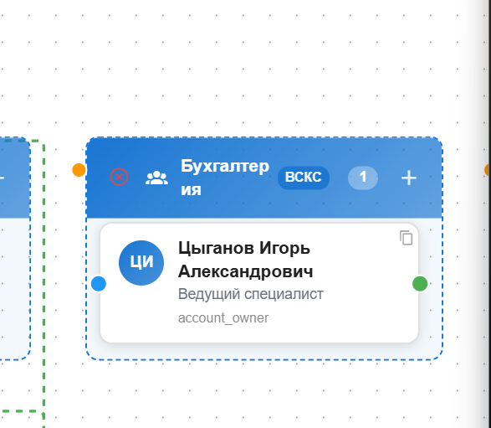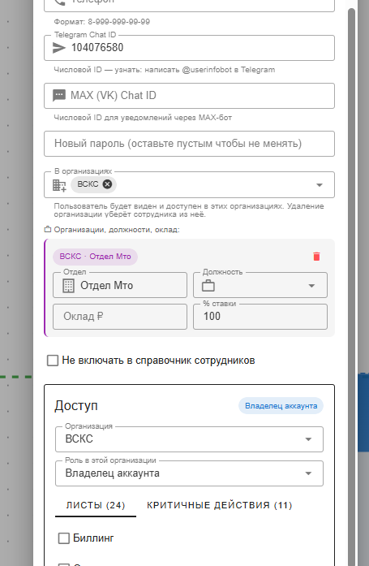

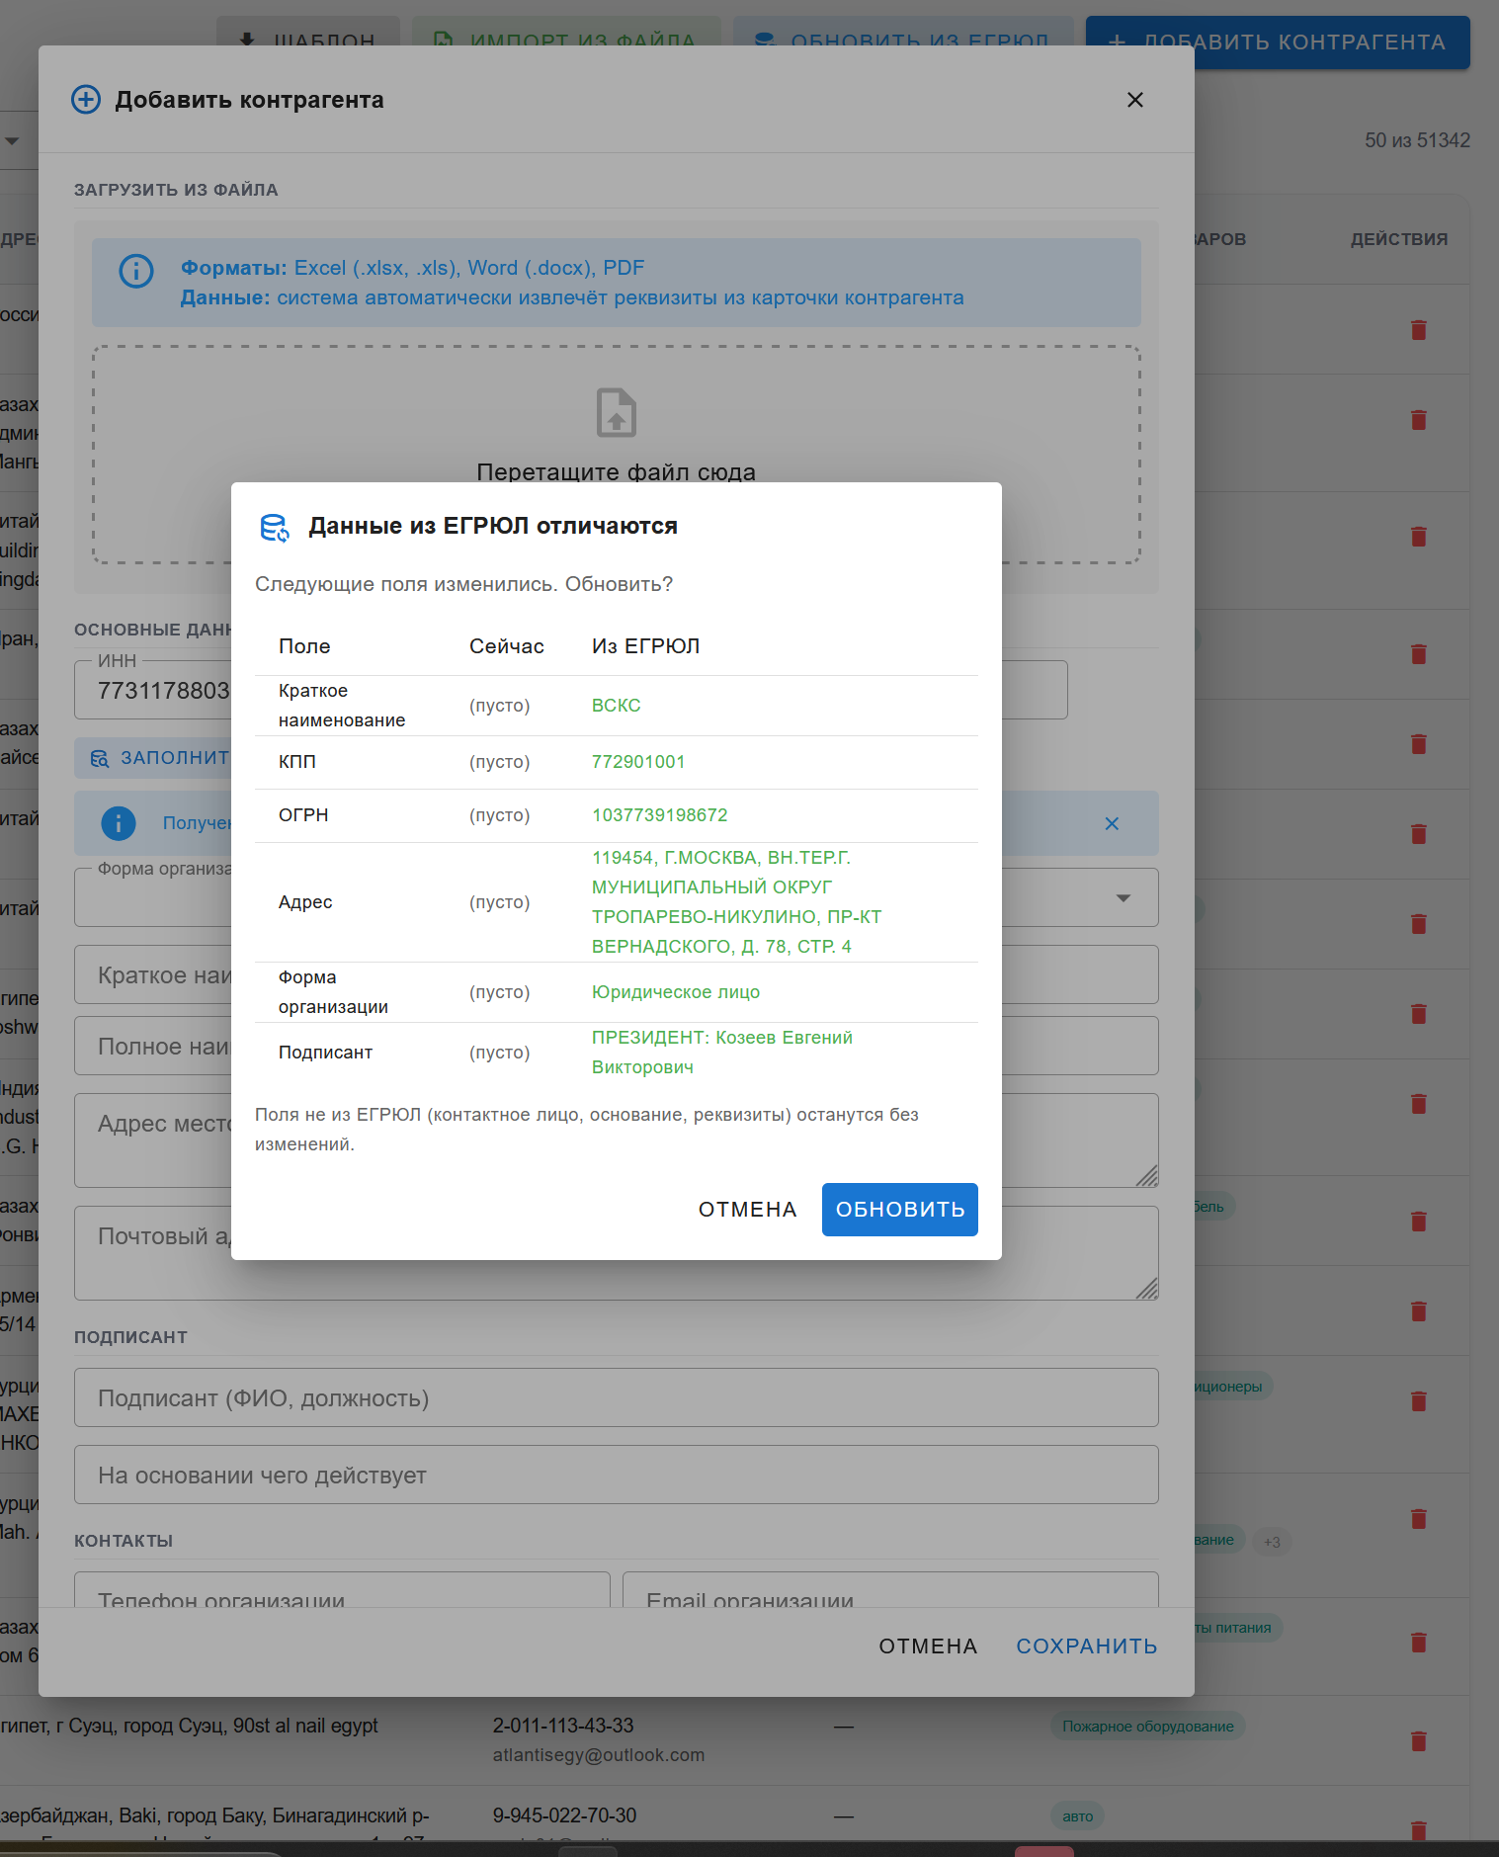Пытаюсь добавть конрагента , ввожу ИНН, я точно знаю что этот контрагент уже есть, более того это ВСКС к которому привязаны субсидии. Но Програма не проверяет БД, на то что такой контрагент уже имеется и даёт информацию, что сейчас пусто. Надо чтобы проверялась БД и если контрагент есть, сообщало об этом и перекидывало в его карточку.
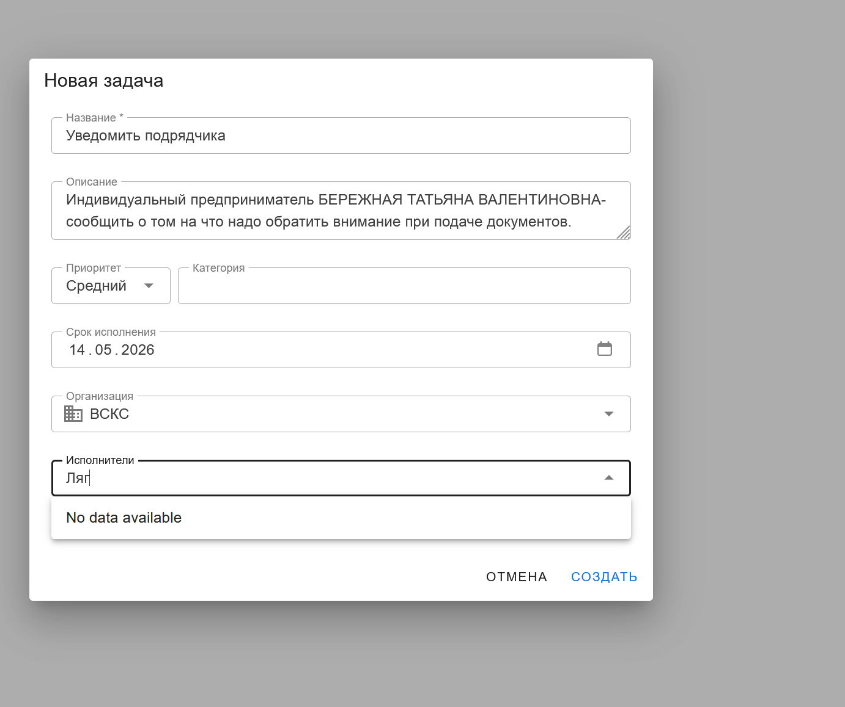
Ставлю новую задачу, но не могу выбрать исполнителя. Нет выпадающего списка, ну и само собой нужен life фильтр. Наверное сотрудник может ставить задачи для всех сотрудников во всех организациях где он присутствует. Разумеется соблюдая условия принятия задачи или безусловной постановки в соответтсвии с подчинённостью.

